LAB TRANSFORMATION
Họ tên: Trần Anh Khoa
MSSV: 2211644
Bài 1:
Hình 1:
Vẽ grid ngang:
for(int i = WINDOW_BOTTOM; i<WINDOW_TOP; i++){
//Code here 1
glVertex2i(WINDOW_LEFT, i);
glVertex2i(WINDOW_RIGHT, i);
}
Vẽ nhà:
void drawHouse(){
glLineWidth(3.0);
//Code here 2
glBegin(GL_LINE_LOOP);
glVertex2i(0, 0);
glVertex2i(4, 0);
glVertex2i(4, 2);
glVertex2i(2, 4);
glVertex2i(0, 2);
glEnd();

glBegin(GL_LINE_LOOP);
glVertex2f(1.5f, 3.5f);
glVertex2f(1.5f, 4.0f);
glVertex2f(0.5f, 4.0f);
glVertex2f(0.5f, 2.5f);
glEnd();
}

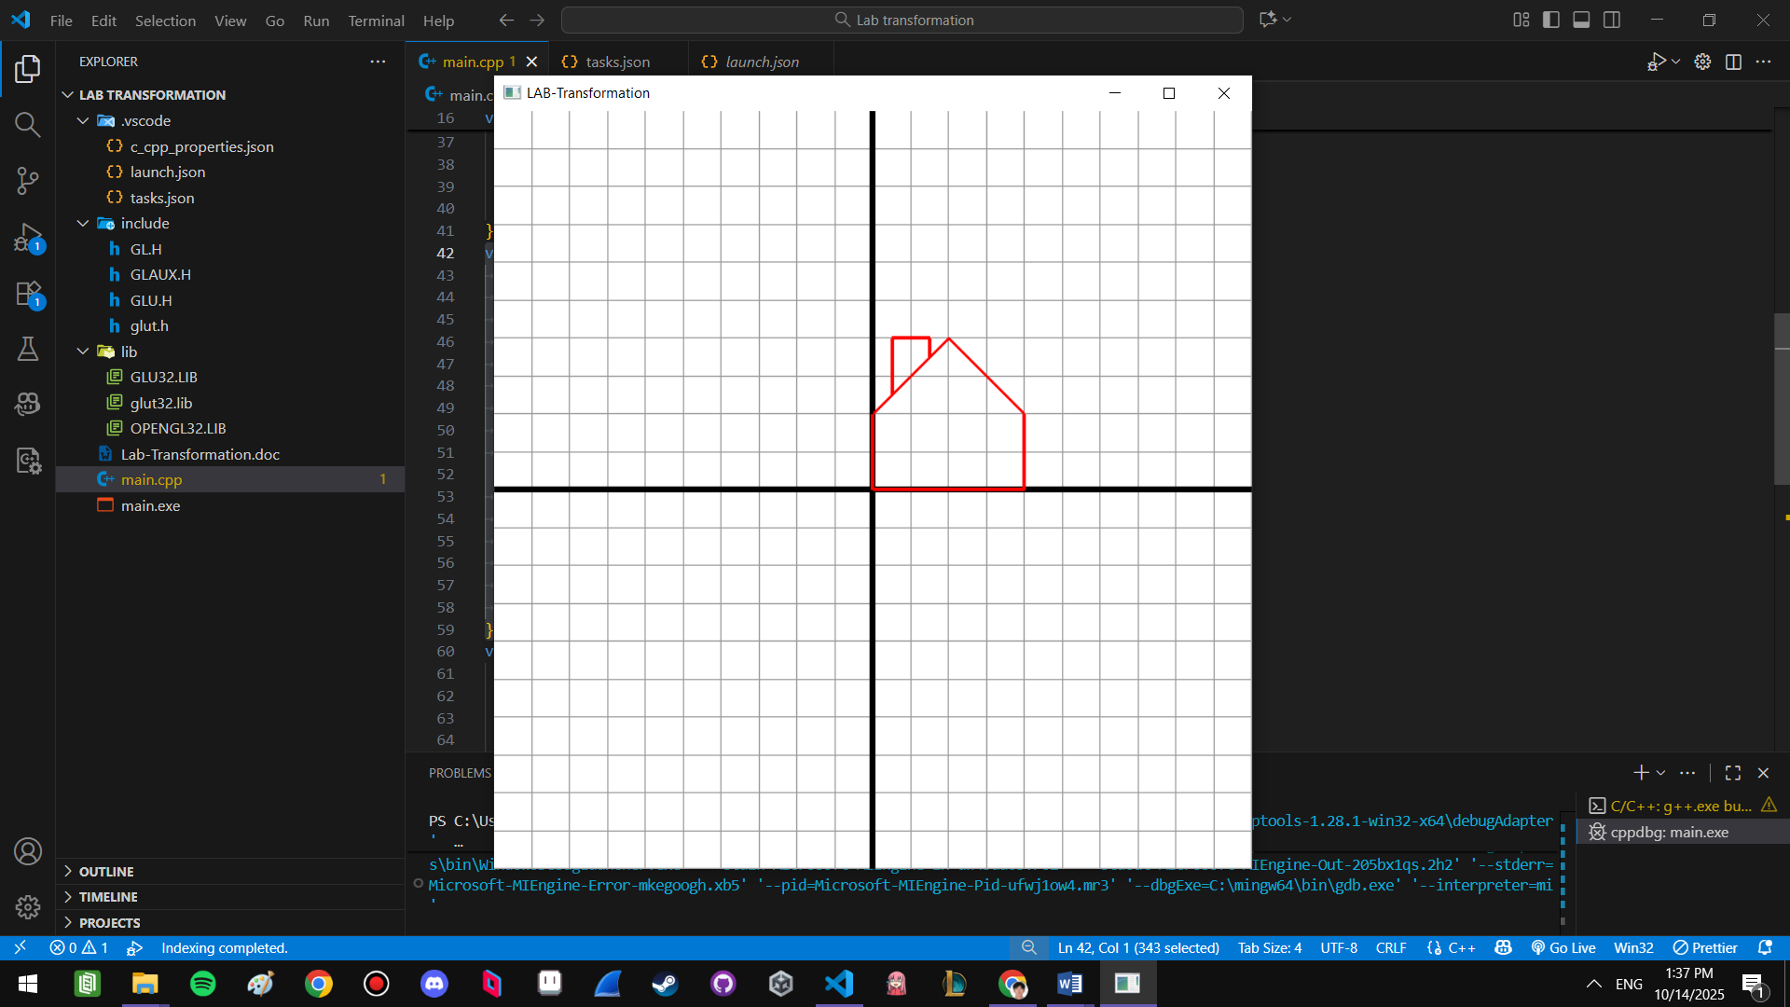
Hình 2:
void myDisplay() {
glClear(GL_COLOR_BUFFER_BIT);
drawGrid();

// Hinh 2
glPushMatrix();
glTranslatef(4.0f, 3.0f, 0.0f);
glColor3f(0.0f, 0.0f, 1.0f);
drawHouse();
glPopMatrix();

glFlush();
}

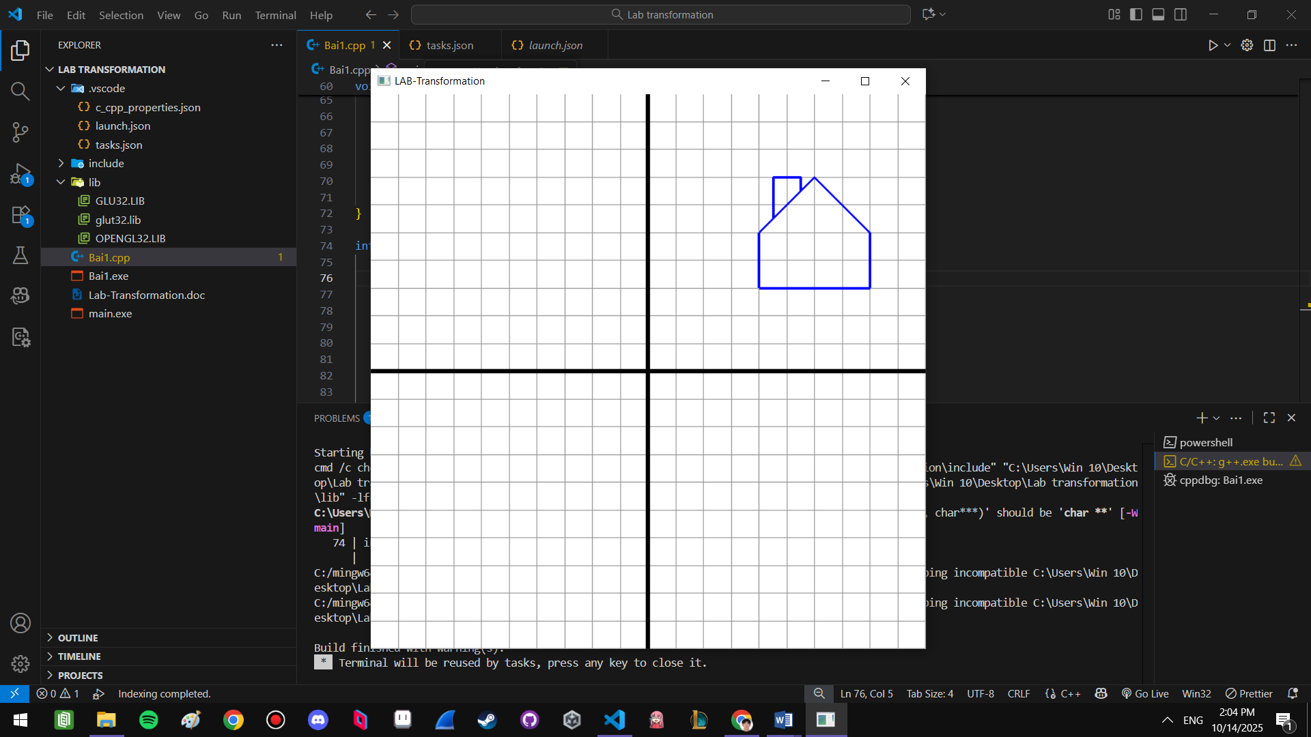

Hình 3:
//Hinh 3
glPushMatrix();
glTranslatef(2.0f, -3.0f, 0.0f);
glScalef(1.0f,1.5f,0.0f);
glColor3f(1.0f, 0.0f, 1.0f); //Mau hong
drawHouse();
glPopMatrix();
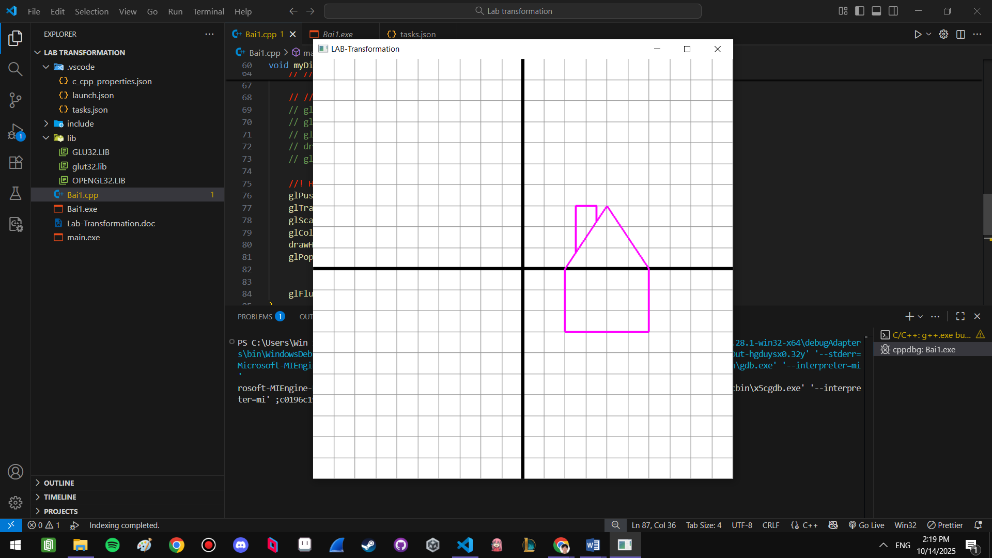
Hình 4:
// Hinh 4
glPushMatrix();
glTranslatef(0.0f,2.0f,0.0f);
glRotatef(90,0,0,1);
glColor3f(0.0f,1.0f,1.0f);
drawHouse();
glPopMatrix();

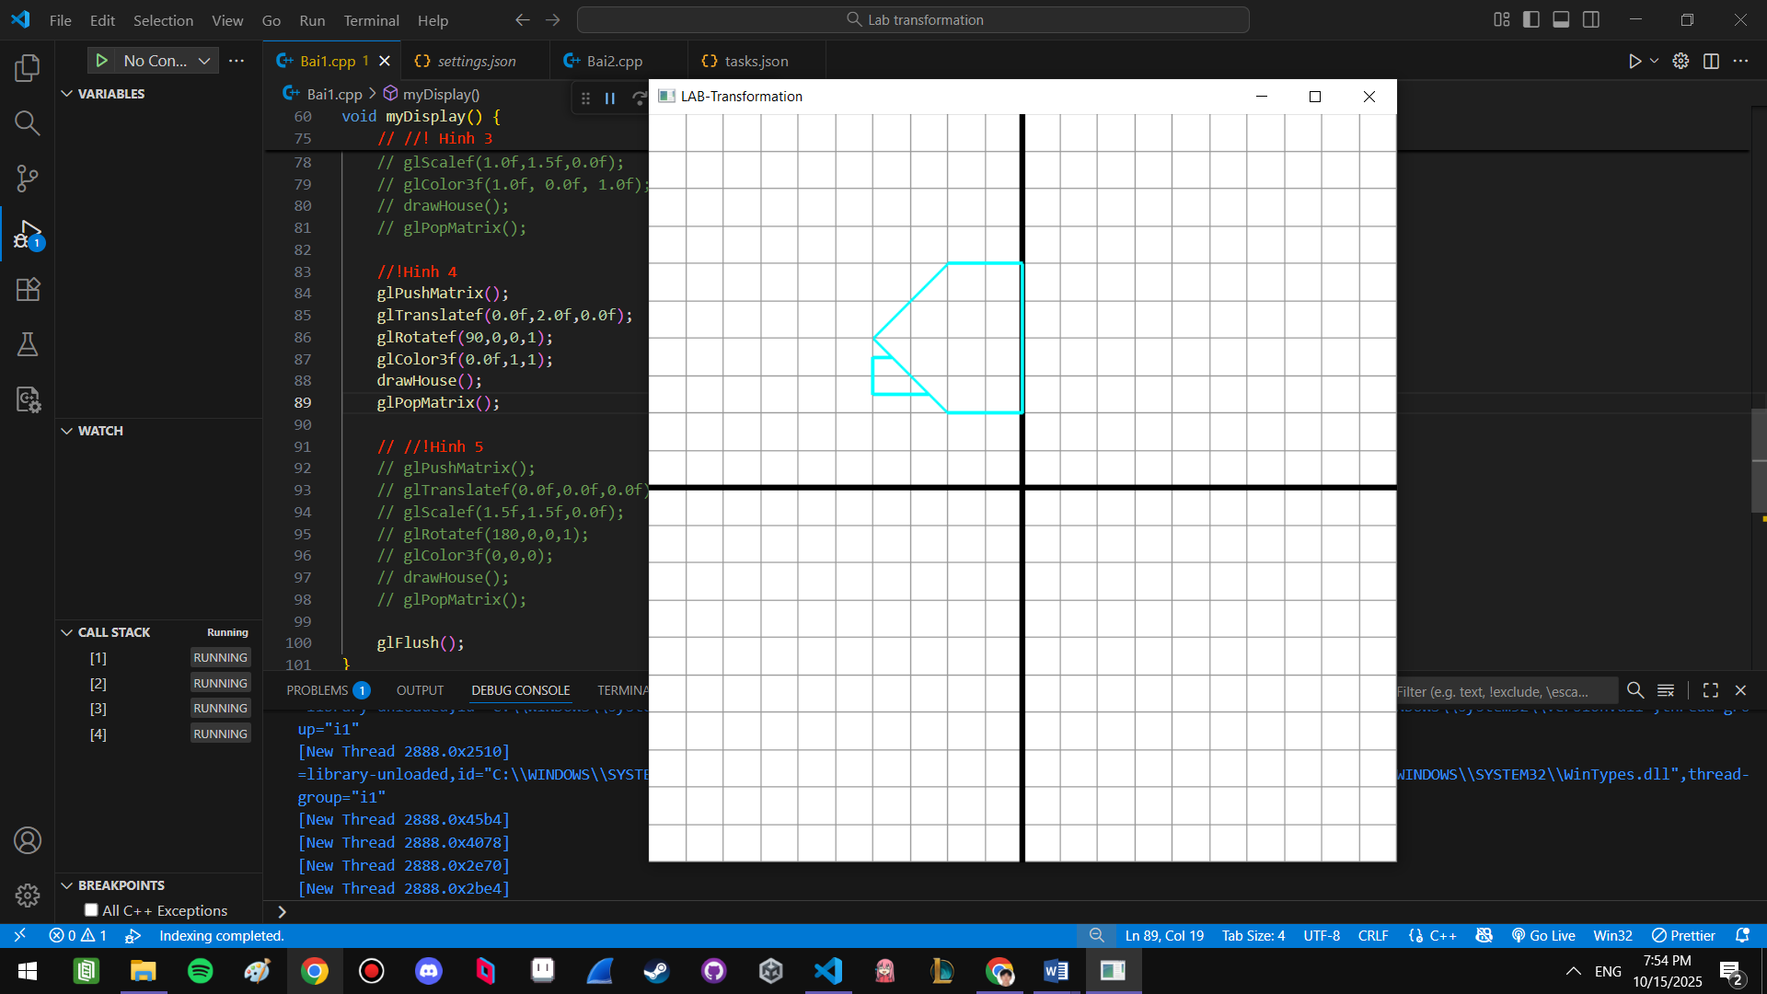

Hình 5:
Các phép biến đổi là
- Phép quay xung quanh góc tọa độ một góc 180 độ
- Phép biến đổi tỷ lệ với Sx=1.5, Sy= 1.5
//Hinh 5
glPushMatrix();
glScalef(1.5f,1.5f,0.0f);
glRotatef(180,0,0,1);
glColor3f(0,0,0);
drawHouse();
glPopMatrix();

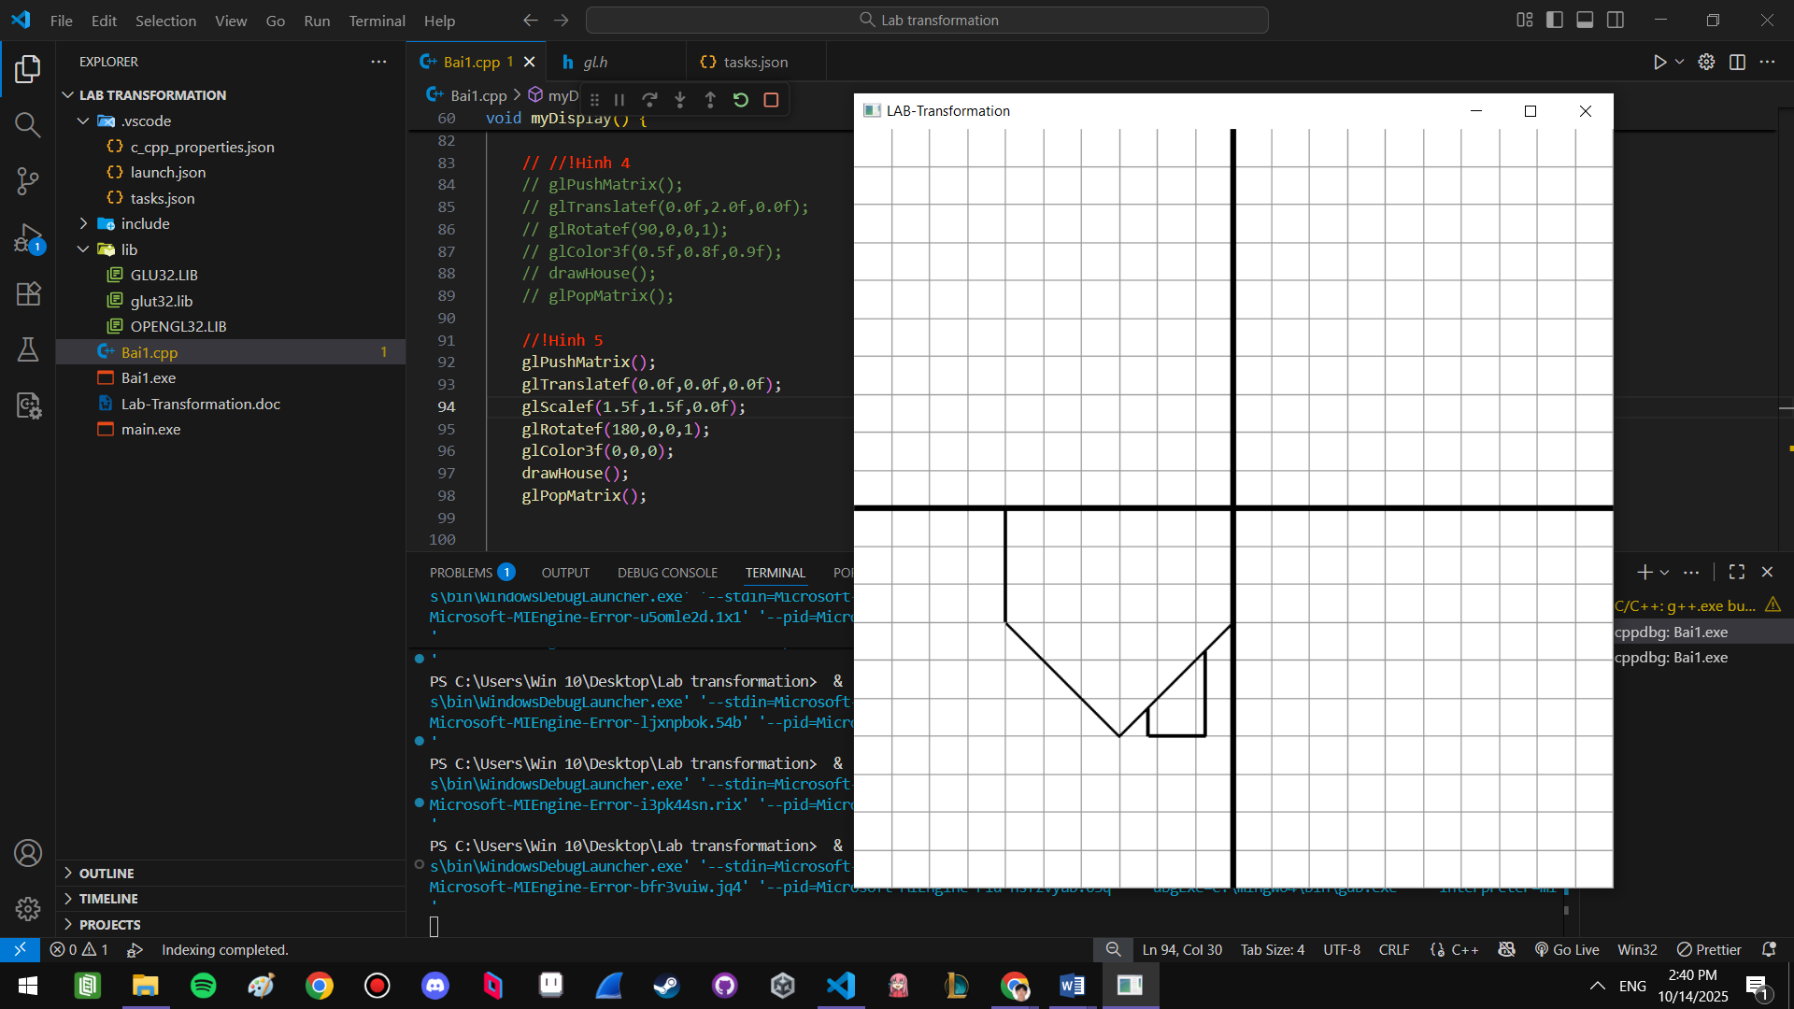

Hình 6:
// Hinh 6
void myDisplay() {
glClear(GL_COLOR_BUFFER_BIT);
drawGrid();

//!Hinh 1
glColor3f(1.0f, 0.0f, 0.0f);
drawHouse();

//! Hinh 2
glPushMatrix();
glTranslatef(4.0f, 3.0f, 0.0f);
glColor3f(0.0f, 0.0f, 1.0f);
drawHouse();
glPopMatrix();

//! Hinh 3
glPushMatrix();
glTranslatef(2.0f, -3.0f, 0.0f);
glScalef(1.0f,1.5f,0.0f);
glColor3f(1.0f, 0.0f, 1.0f);
drawHouse();
glPopMatrix();

//!Hinh 4
glPushMatrix();
glTranslatef(0.0f,2.0f,0.0f);
glRotatef(90,0,0,1);
glColor3f(0.5f,0.8f,0.9f);
drawHouse();
glPopMatrix();

//!Hinh 5
glPushMatrix();
glTranslatef(0.0f,0.0f,0.0f);
glScalef(1.5f,1.5f,0.0f);
glRotatef(180,0,0,1);
glColor3f(0,0,0);
drawHouse();
glPopMatrix();

glFlush();
}

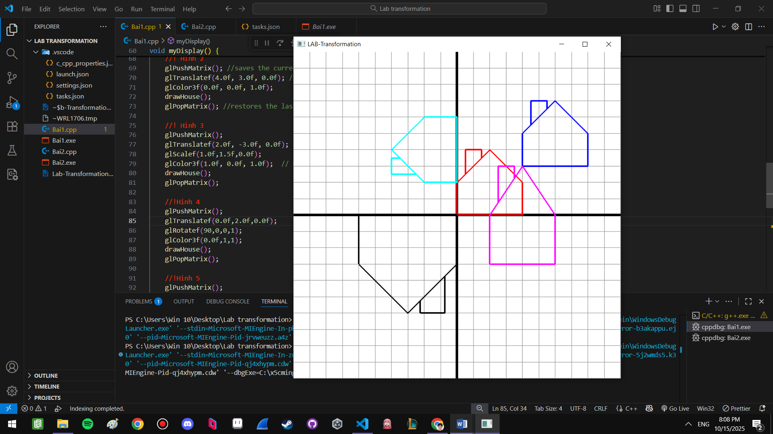

Bài 2:
1)
glPushMatrix();
glTranslatef(1,0,0);
glutSolidTeapot(0.25);
glPopMatrix();

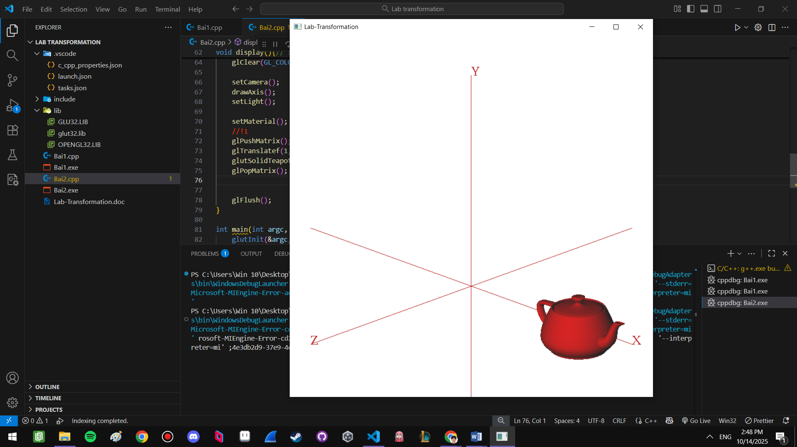

2)
//Box
glPushMatrix();
glScalef(0.5, 1.0, 0.9);
glTranslatef(0.5,0.5,0.5);
glutWireCube(1.0);
glPopMatrix();

//Teapot
glPushMatrix();
glTranslatef(0.5,1,0.9);
glutSolidTeapot(0.25);
glPopMatrix();

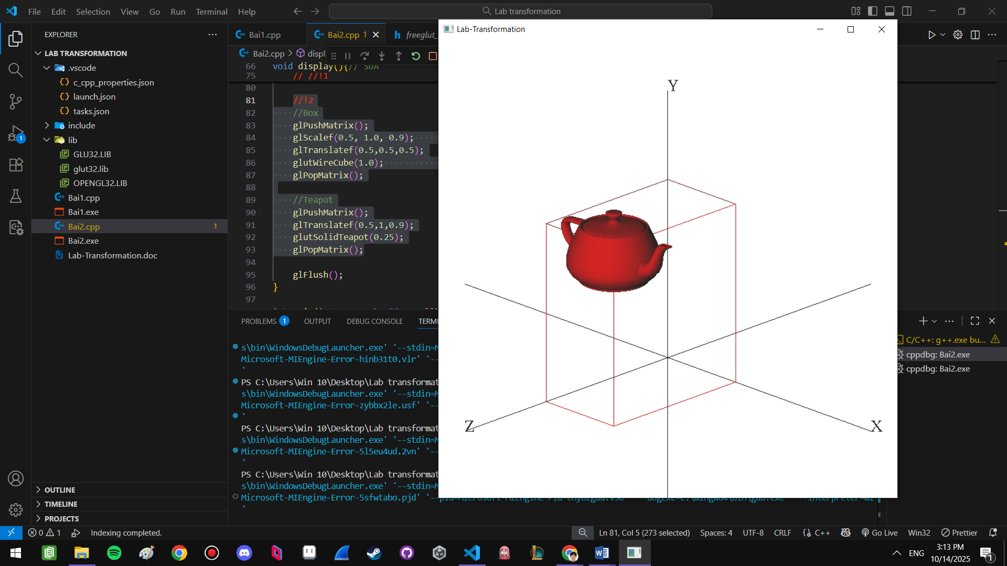
3)
glPushMatrix();
glTranslatef(0,0,1);
glutSolidTeapot(0.25);
glPopMatrix();

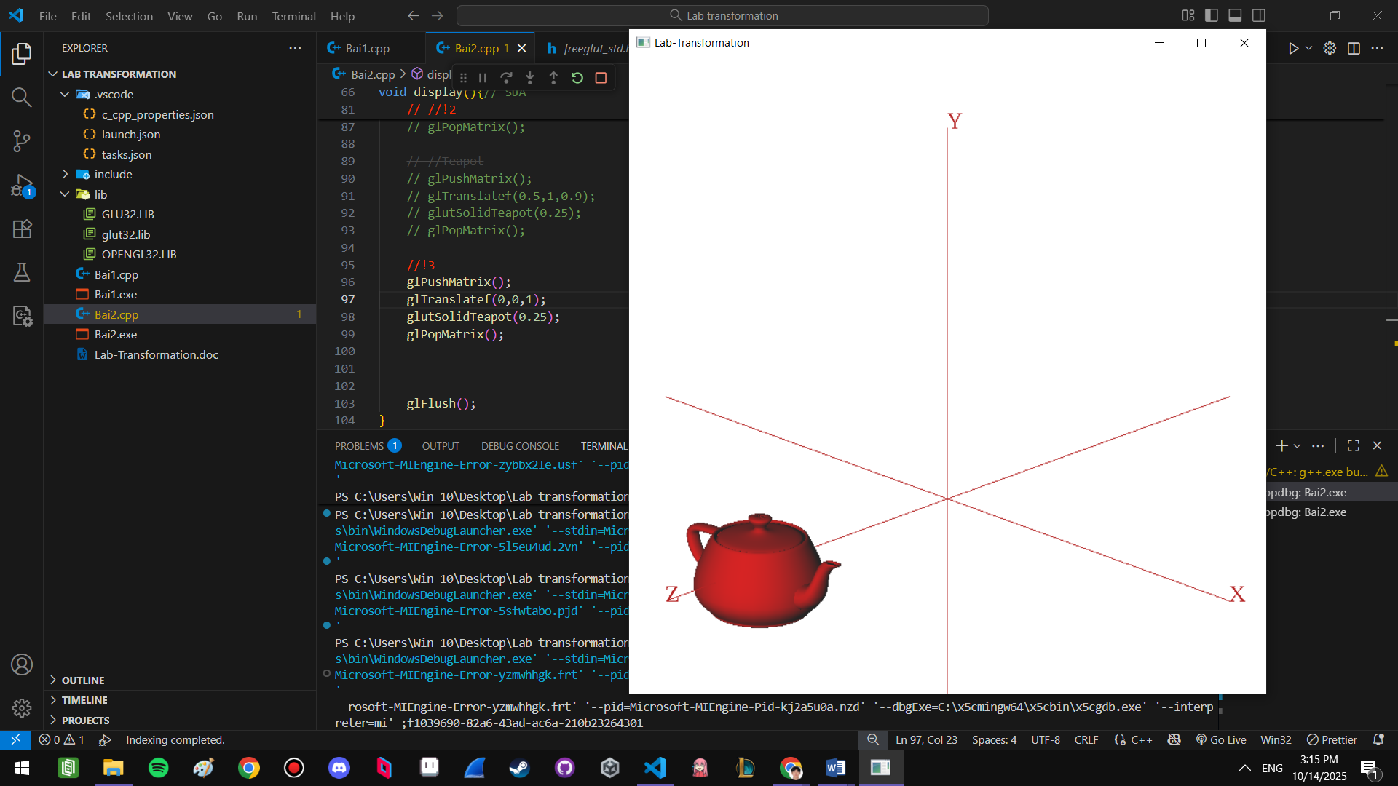
4)
glPushMatrix();
glRotatef(60,0,1,0);
glTranslatef(0,1,0);
glutSolidTeapot(0.125);
glPopMatrix();

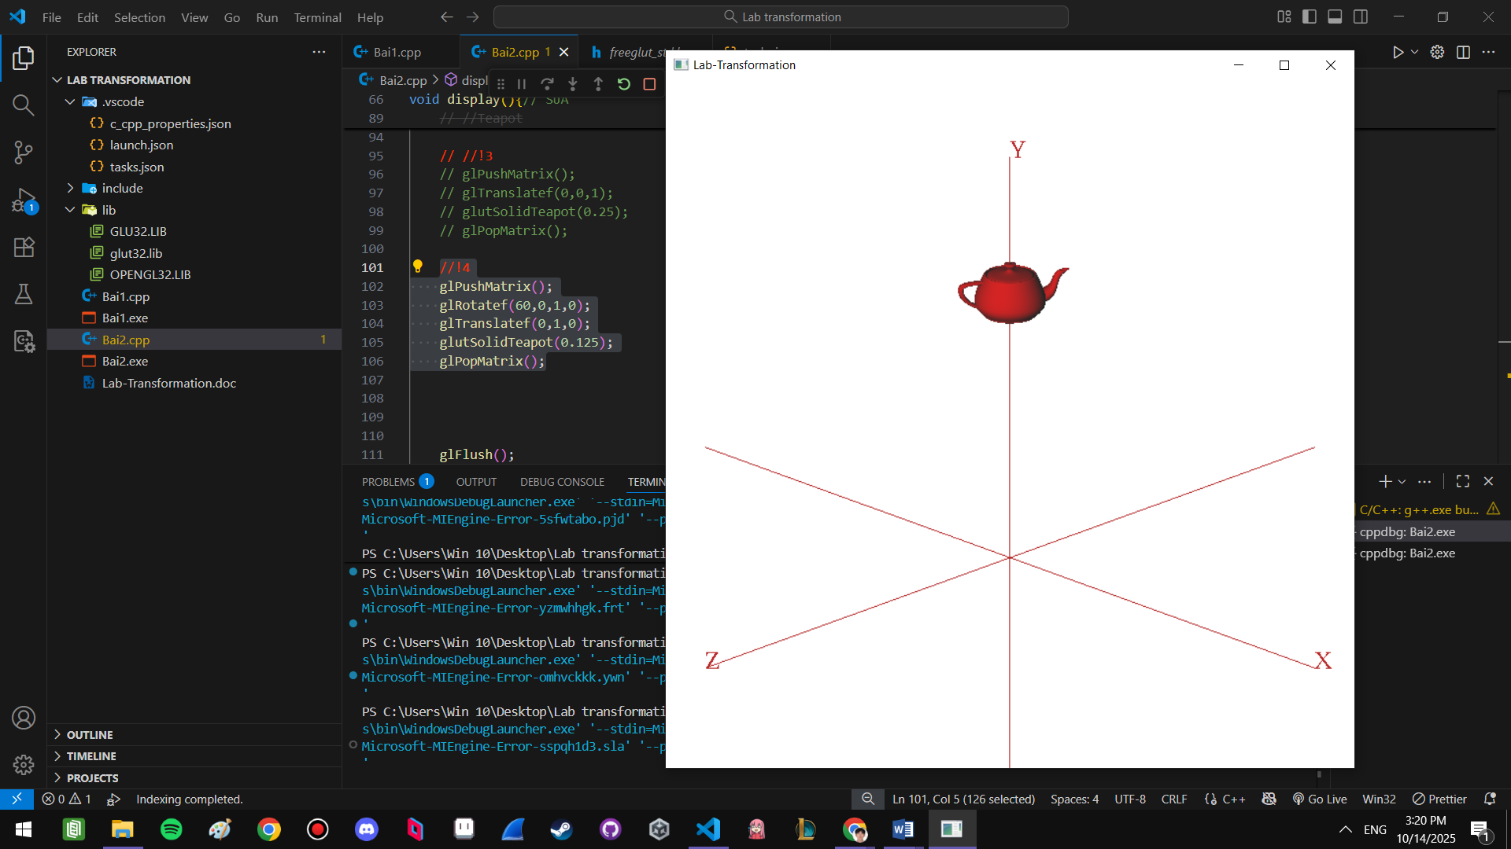

5)
glPushMatrix();
glTranslatef(0,0,1);
glRotatef(270,0,1,0);
glutSolidTeapot(0.25);
glPopMatrix();

glPushMatrix();
glTranslatef(0,0,-1);
glRotatef(90,0,1,0);
glutSolidTeapot(0.25);
glPopMatrix();

glPushMatrix();
glTranslatef(1,0,0);
glutSolidTeapot(0.25);
glPopMatrix();

glPushMatrix();
glTranslatef(-1,0,0);
glRotatef(180,0,1,0);
glutSolidTeapot(0.25);
glPopMatrix();

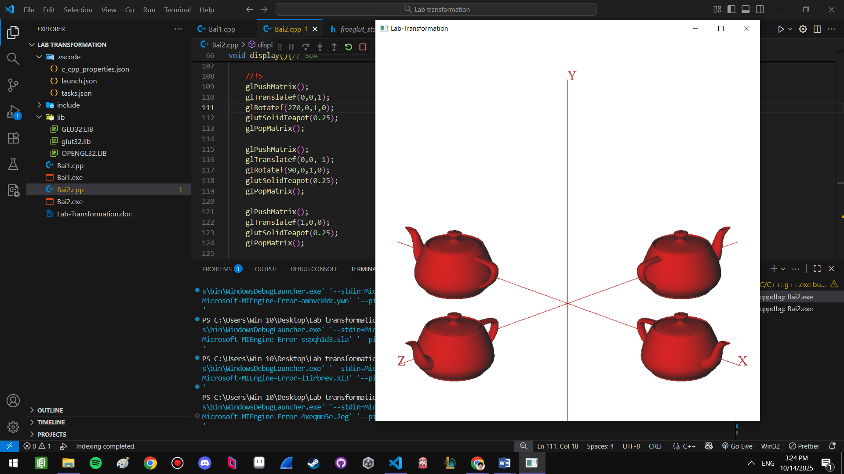

6)
glPushMatrix();
float scale = 1.0f;
float y = 0.0f;

for (int i = 0; i < 5; i++) {
glPushMatrix();
glTranslatef(0.0f, y, 0.0f);
glScalef(scale, scale, scale);
glutSolidTeapot(0.25);
glPopMatrix();

y += 0.3f;
scale *= 0.8f;
}
glPopMatrix();

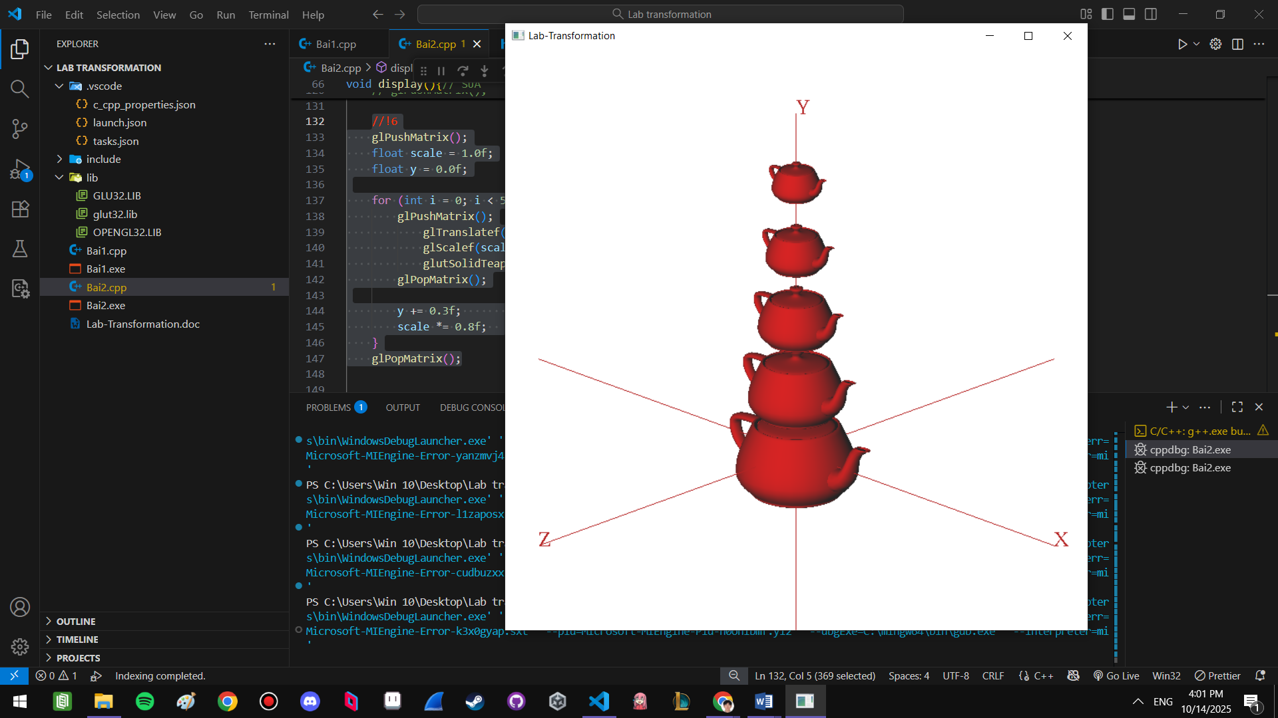
7)
glPushMatrix();
for (int axis = 0; axis <2; axis ++)
{
int j=5;
for (int i=0;i<5;i++)
{
for (int k=0;k<j;k++){
glutSolidCube(0.15f);
glTranslatef(0.225f,0,0);
}
if (axis ==0) glTranslatef(-0.225f*j,0,0.225f);
else glTranslatef(-0.225f*j,0.225f,0);
j--;
}
glTranslatef(-0.225f*j,0,-5*0.225f);
}
glPopMatrix();
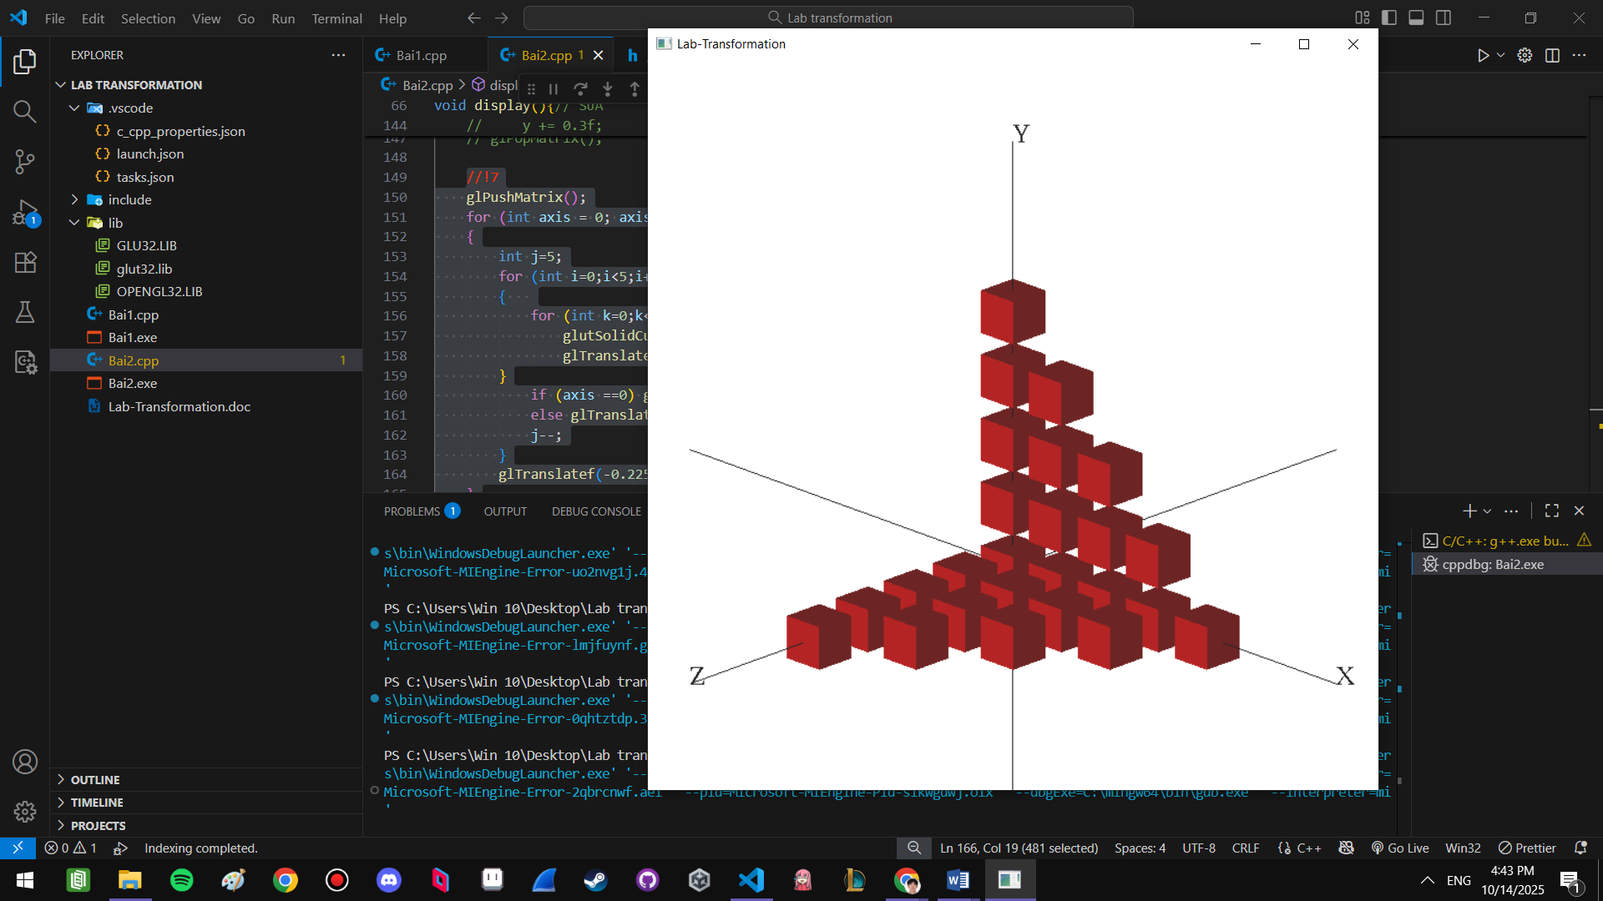

8)
for (int axis = 0 ; axis <3; axis ++){
glPushMatrix();
float scale = 1.0f;
float d = 0.0f;
float rotateAngle = 0;
int i=0;

for (i; i < 5; i++) {

glPushMatrix();
if (axis ==0) {
glTranslatef(0.0f, d, 0.0f);
glRotatef(rotateAngle,0,1,0);
}

else if (axis ==1) {
glTranslatef(d, 0.0f, 0.0f);
glRotatef(rotateAngle,1,0,0);

}
else {
glTranslatef(0.0f, 0.0f, d);
glRotatef(rotateAngle,0,0,1);
}
glScalef(scale, scale, scale);
glutSolidCube(0.2);
glPopMatrix();

d += 0.5*(scale*0.2+scale*0.2*0.8);
scale *= 0.8f;
rotateAngle +=45;
}
float goBackDistance;
for (int j=0;j<i;j++){
if (j==0 || j==i-1) goBackDistance += pow (0.8,j);
else goBackDistance += pow(0.8,j) *2;
}
if (axis ==0) glTranslatef(0.0f, -0.5*goBackDistance, 0.0f);
else if (axis ==1) glTranslatef(-0.5*goBackDistance, 0.0f, 0.0f);
else glTranslatef(0.0f, 0.0f, -0.5*goBackDistance);

glPopMatrix();
}

